Raynham Parish Council
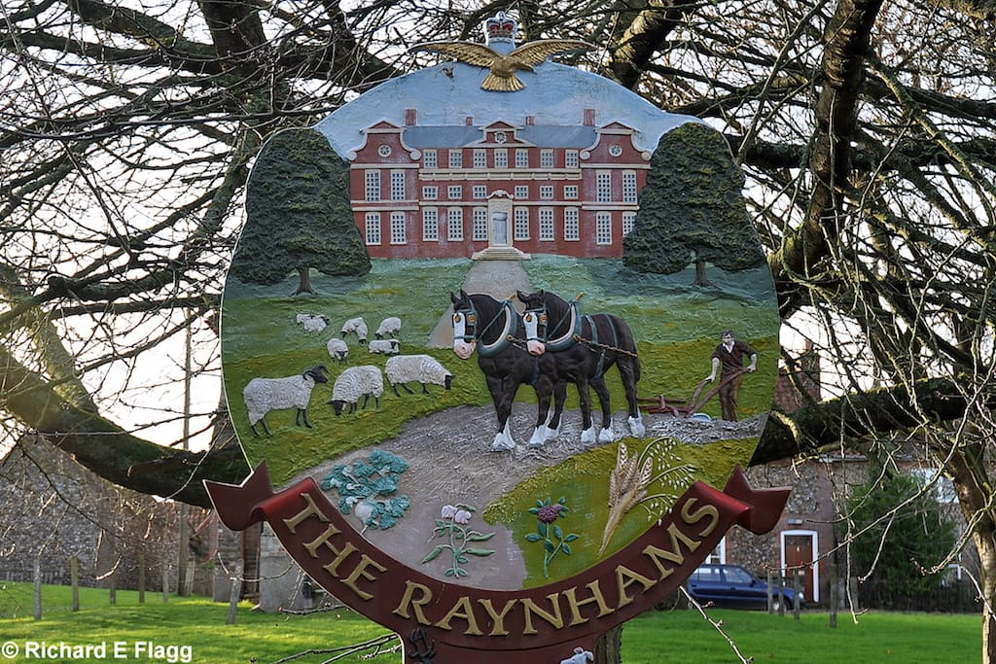
Meeting Agenda
Date: Tuesday 25th November 2025
Time: 7pm
Place: West Raynham Village Hall

I hereby give notice of a meeting of Raynham Parish Council to be held on Tuesday 25th November 2025 at 7pm. Councillors are hereby summoned to attend for the purpose of transacting the business on the agenda. Raynham Parish Council welcomes the public and press to its meetings. The public and press are able to address the Council during the Public Participation session. The law does not permit members of the public and press to take part in the debates.
Maxine Hayes

1. Welcome and to receive apologies for absence
2. To receive declarations of interest in items on the agenda and consider any requests for dispensations
3. To approve the minutes of meeting held on 16th September 2025
4. To report progress on items not on the agenda from the last meeting
5. To hear from the District Councillor and County Councillor, if attending
6. Open forum for Public Participation: an opportunity to hear from members of the public
7. Open Spaces
7.1 Discuss and report any highways issues
7.2 Receive SAM2 data report
7.3 Update on 20mph zone outside West Raynham school
7.4 Update on new Bus Shelter
7.5 Play area
7.6 Lakeside permissive path (carried forward from Sept meeting)
8. Planning Matters
8.1 To receive results of applications
8.2 To receive and consider new applications
9. Receive and consider any correspondence
10. Financial Matters
10.1 To approve the bank reconciliation and payment of accounts list
10.2 Assertion 10 new data and digital compliance regulations – (report circulated from Clerk)
10.3 To review budget and set precept for 2026/27
11. To receive any items for inclusion on the next agenda and to note the date of the next meeting
Date of next meeting: 27th January 2025

